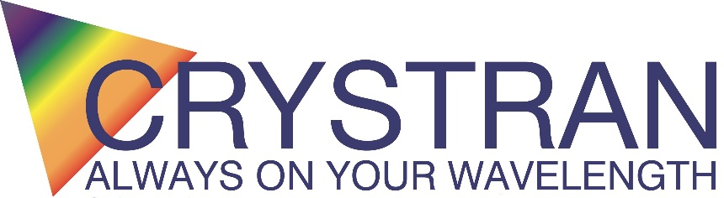
Crystran Ltd
Unit 1 Broom Road Business Park
Poole
Dorset United Kingdom
Tel: +44 (0) 1202 307650
www.crystran.com

Quotation: APR44409

Date: 16/10/2026
Contact Name: Dr. Oluwatobi Busari Your contact: Mandy Robinson
Company: Morgan state University Email: Mandy@crystran.co.uk

Description | Quantity | Price per piece GBP | Approx.  Lead time
Fused Silica wedge 75mm dia x 12mm thick ( thin end)  2° wedge  CA 63.5°  AR coated on both faces 550-1100 nm, R<1.5% ave…for 300 nm R<2%, | 6 | £1200.00 | 10 weeks
Carriage will be charged at the cost per delivery.

Notes
(Principal Investigator), Morgan State University, 1700 East Cold Spring Lane, Baltimore, MD 21251, in US dollars, and send it to me at mabad5@morgan.edu.

Quotations valid for 30 days (Due to ongoing price instability of Germanium material, quotations including Ge are subject to change when underlying costs of material fluctuate by +/-5% from the quotation date).
All items are offered uncoated unless specifically stated on the quotation.
All coated items from free issue material are offered coated at your own risk.
Quotation does not include VAT (if applicable).
For orders over £500 paid by credit card, a 5% charge will apply.
Payment Terms: 30 days from invoice for account holders, payment against proforma invoice for new customers.
Shipping Terms: All shipments will be made on a CIP basis. Cost of carriage will be added to the final invoice.
If you require the goods to be shipped on your account with your nominated courier, the terms will be FCA Poole and insurance of the shipment must be arranged by the consignee.
If you are purchasing these items from outside the UK, goods entering your country may incur import duties and taxes. Crystran Ltd is not responsible for these charges, which must be paid on delivery of the goods.
Due to changes in the EU import rules (taking effect 01-11-2026) all shipments valued under €150.00 will no longer be covered under the de minimis exception and will now be subject to a nominal duty per line item on customs declaration. It is the responsibility of the buyer to pay these duties to the relevant authorities.
Any Offer to Supply is subject to the Standard Conditions of Sale of Crystran Ltd which may be found at
https://www.crystran.com/wp-content/uploads/2025/09/conditions-of-sale.pdf
Unless otherwise specified:
Surface quality is assessed against MIL 13830 using Davidson Optronics D667 comparator plates SN:2444.
Surface Roughness measured on a roughness interferometer over a 1.8 x 1.8mm area using a 0.08mm spatial (gaussian) filter as per ISO 10110

Best regards,
Amanda Robinson
On behalf of Crystran Ltd.

